ORACLE EXERCISE PROBLEM

1)

BODY MASS INDEX CALCULATOR

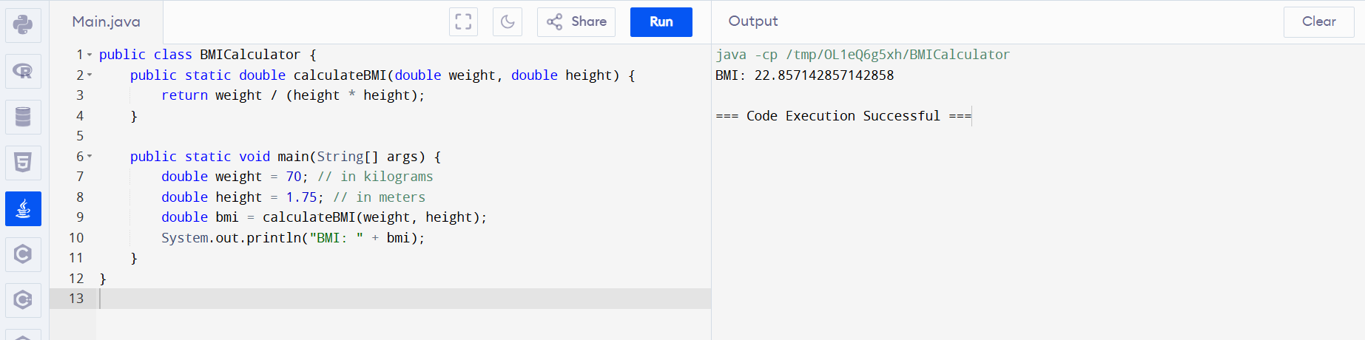

2)

MAX AND MIN AGE OF PERSON

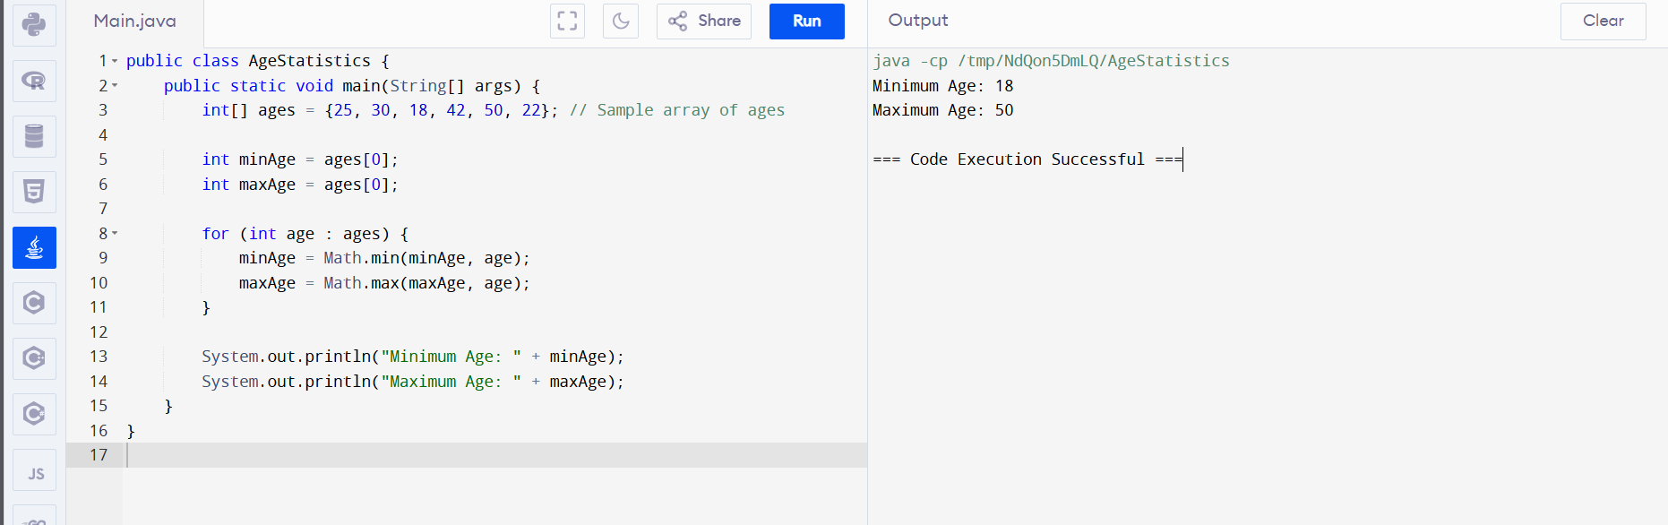

3)

SQUARE ROOT

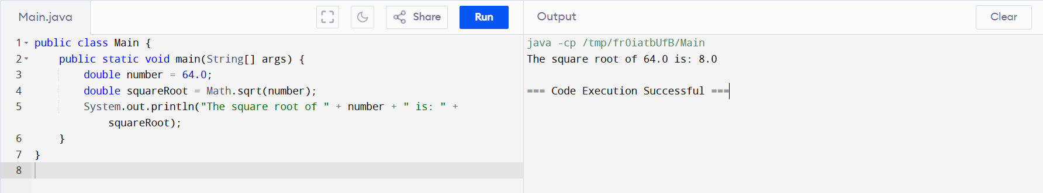

4)